ARTYFY

Project Team - 5

COMP8117 Fall 2021

**Sprint - 5 Report**

# **Objectives of the sprint**

The objective of the sprint is the deployment and release of our application to general public. This sprint includes details such as completing the filter by art categories feature, integration of Art finder machine learning code to our application, deployment, completing and bug fixes required after deployment , overall system testing and finishing all the required documentation for our application.

# **Tasks**

* **Scrum meetings**

Conducted the scrum meetings in the team to gather the requirements which are provided by the customer and discussed the progress and implementation throughout the sprint.

* **Meeting with customer**

Customer gave related inputs and validation is done for every screen present and for milestone meeting, required presentations, live demo & feedback is taken at end of sprint.

* **Spécifications**
* **Filter by Art categories**

**Introduction:**

To be able to filter the art based on various categories while viewing.

**Inputs**

User will click on the filter feature while viewing art and they will be able to choose from various categories available.

**Processing**

Basing on the selection of the filter by the user while viewing art, the art belonging to only that category will be retrieved from the database and viewed on the screen.

**Output**

Users can view all the art of a particular category by using the filter feature and the list of artists and their respective art in that category will be displayed.

* **Art Finder**

**Introduction:**

To take the image provided by the user and find similar images in the same that can be processed using algorithm.

**Inputs:**

User uploads a picture from the UI screen and then, this image reaches the algorithm for further processing.

**Processing**:

When user uploads a picture from the screen, it reaches the Art Finder algorithm for further processing in which it undergoes through loading the image and passing the image through firebase. The algorithm checks for the image and then it is saved to the database for future references. The algorithm further provides similar images in that genre for user to view.

**Output:**

Various images similar to the one user uploaded will appear on the screen with information on that genre.

**Miscellaneous Tasks:**

There were miscellaneous tasks that includes integration issues with integration bugs, completing backlogs, and testing the current sprint.

**Design** -

We are using art available in the data base for this. The user must have good internet so that the art filtered can be retrieved from the database and viewed. Picture quality art is dependent on the hardware specification of device of artist.

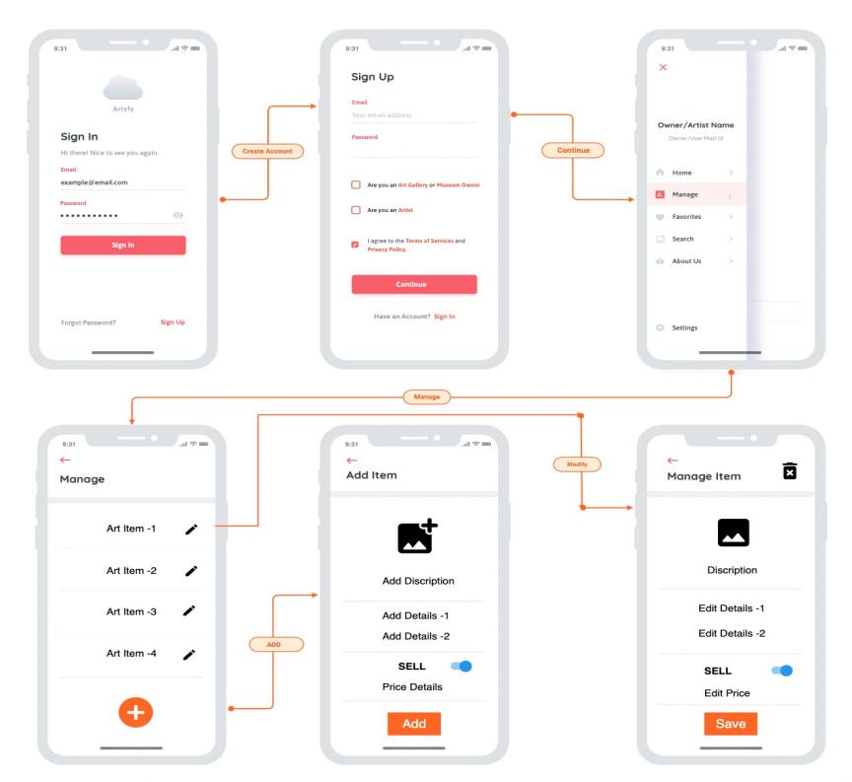

Figure : Mock UP for edit art

**Implementation –**

Users can view all the art of a particular category by using the filter feature and the list of artists and their respective art in that category will be displayed.

**Maintenance-**

Once the application is deployed, and the system meets all the approval, regular maintenance of the database and the application needs to be done. We will continue to improve and maintain the changes by releasing further updates.

**Test**

Overall testing should be done on view list of artists feature, visibility of artists and art to end user, operations on art items, buy feature, Art finder feature, validation of payment information ,synchronizing of changes should be done.

1. **Provisional Planning of the Sprint**

|  |  |  |  |  |  |  |
| --- | --- | --- | --- | --- | --- | --- |
| **Task** | **PSD** | **PED** | **Expected Duration** | **Expected Assignee** | **Dependent Tasks** | **Expected artifacts** |
| Filter by Art categories | Dec 1 | Dec 2 | 5h | Shruthi | 91 |  |
| Deployment & Release | Dec 1 | Dec 2 | 5h | Bhargav | 92 |  |
| Bug fixes after Deployment | Dec 1 | Dec 2 | 5h | Yuva | 93 |  |
| System Testing : Overall | Dec 1 | Dec 5 | 4d 4h | Varun  Deepak  Narayanan  Nupur | 96 |  |
| Project Management : Sprint - 5 | Dec 2 | Dec 3 | 1d 6h | Yuva  Deepak  Varun  Bhargav  Pravallika  Shruti  Narayanan  Nupur | 157 |  |
| Documentation- Sprint 5 | Dec 1 | Dec 2 | 5h | Pravallika | 158 |  |
| Overall Documentation | Dec 5 | Dec 8 | 3d | Yuva  Deepak  Varun  Bhargav  Pravallika  Shruti  Narayanan  Nupur | 159 |  |

1. **Effective Planning**

|  |  |  |  |  |  |  |  |
| --- | --- | --- | --- | --- | --- | --- | --- |
| **Task** | **Related Tasks** | **PSD** | **PED** | **Expected Duration** | **Expected Assignee** | **Dependent Tasks** | **Expected artifacts** |
| Filter by Art categories |  | Dec 1 | Dec 2 | 5h | Shruthi | 91 |  |
| Deployment & Release |  | Dec 1 | Dec 2 | 5h | Bhargav | 92 |  |
| Bug fixes after Deployment |  | Dec 1 | Dec 2 | 5h | Yuva | 93 |  |
| System Testing : Overall | 1)Art owner Persona Testing  2) Artist Persona  3) algorithm Testing  4) user Persona | Dec 1 | Dec 5 | 4d 4h | Varun  Deepak  Narayanan  Nupur | 96 |  |
| Project Management : Sprint - 5 | 1)Daily Scrum  2) Final Peresentation  3) Sprint Planning | Dec 2 | Dec 3 | 1d 6h | Yuva  Deepak  Varun  Bhargav  Pravallika  Shruti  Narayanan  Nupur | 157 |  |
| Documentation- Sprint 5 |  | Dec 1 | Dec 2 | 5h | Pravallika | 158 |  |
| Overall Documentation |  | Dec 5 | Dec 8 | 3d | Yuva  Deepak  Varun  Bhargav  Pravallika  Shruti  Narayanan  Nupur | 159 |  |

**w : week

d : day

h : hours

1. **Review**

* Final deployment and release of the application has been done perfectly.
* Overall bug testing after deployment has been performed.
* We found issues integrating the python code of the art finder feature to our application, we are planning on resolving and fully integrating the art finder feature while working on the next update for our application.
* We are looking to expand the multi nature of our project for interior designers, makeup artists and many more where it is easy to categorise art.
* We will be providing premium items in the future for bidding.
* When application gets a little bit popularity, we plan to add subscription for the artists and users.
* We have trained our development teams in how to maintain the system. We are looking forward to delivering the latest revisions to our users is a snap, and is completely transparent to our audience.

1. **Retrospective**

* We organized scrum meetings with all the team members based on their availability and communicated regarding our individual contribution and their respective tasks.
* Based on the customer inputs and suggestions we implemented the features and their functionalities accordingly.
* Tasks allocation and time logging was done in Jira.
* As we focused more on the implementation in this sprint, we will also give more preferences towards the documentation such as sprint report, presentation to the customer and other required documents along with the implementation.
* We will complete the deployment and release of the application in the next sprint.